Cloud DFIR: Recap and CloudGoat Practice : rce web app

BoB 13th digital forensic track tranee, DoHwan Ji

To make practice environment, enter these commands in order.

**CloudGoat**

git clone https://github.com/RhinoSecurityLabs/cloudgoat.git

cd cloudgoat

python3 -m venv .venv

source .venv/bin/activate

pip3 install -r ./requirements.txt

chmod +x cloudgoat.py

./cloudgoat.py config profile

./cloudgoat.py config whitelist –auto

**AWS CLI**

curl "https://awscli.amazonaws.com/awscli-exe-linux-x86_64.zip" -o "awscliv2.zip"

unzip awscliv2.zip

sudo ./aws/install

**Terraform**

sudo apt-get update && sudo apt-get install -y gnupg software-properties-common

wget -O- https://apt.releases.hashicorp.com/gpg | \

gpg --dearmor | \

sudo tee /usr/share/keyrings/hashicorp-archive-keyring.gpg > /dev/null

gpg --no-default-keyring \

--keyring /usr/share/keyrings/hashicorp-archive-keyring.gpg \

--fingerprint

echo "deb [signed-by=/usr/share/keyrings/hashicorp-archive-keyring.gpg] \

https://apt.releases.hashicorp.com $(lsb_release -cs) main" | \

sudo tee /etc/apt/sources.list.d/hashicorp.list

sudo apt update

sudo apt-get install terraform

**Prepare python environment**

sudo apt install python3.12-venv

cd cloudgoat/

python3 -m venv .venv

source .venv/bin/activate

**Install CloudGoat dependencies**

pip3 install -r ./requirements.txt

**Create IAM keys**

**Make my Scenario**

./cloudgoat.py create rce_web_app

aws configure --profile cloudgoat

./cloudgoat.py config whitelist --**auto**

./cloudgoat.py create rce_web_app

ws configure --profile Lara

aws ec2 describe-instances --profile Lara

aws elbv2 describe-load-balancers --profile Lara

aws s3 ls s3://cg-logs-s3-bucket-rce-web-app-cgidpwdsii0uiu --recursive -- profile Lara

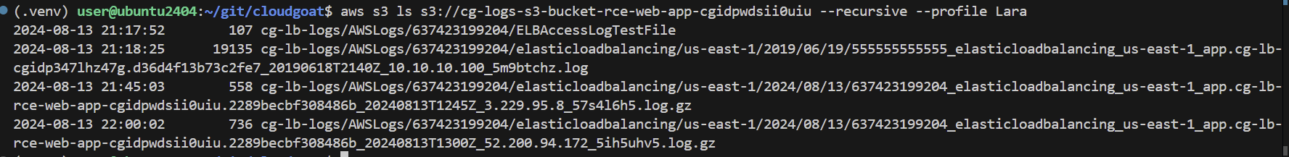

aws s3 cp s3://cg-logs-s3-bucket-rce-web-app-cgidpwdsii0uiu/cg-lb-logs/AWSLogs/637423199204/elasticloadbalancing/us-east-1/2019/06/19/555555555555_elasticloadbalancing_us-east-1_app.cg-lb-cgidp347lhz47g.d36d4f13b73c2fe7_20190618T2140Z_10.10.10.100_5m9btchz.log . --profile Lara

**This command make .csv file which cotains logs. And I can find doubtful url.**  
http 2019-06-18T21:36:46.594569Z app/cg-lb-rce-web-app-cgidpwdsii0uiu/d36d4f13b73c2fe7 10.10.10.23:5132 10.0.10.254:9000 0.001 0.001 0.000 200 200 485 1287 "GET http://cg-lb-rce-web-app-cgidpwdsii0uiu-23394348.us-east-1.elb.amazonaws.com:80/mkja1xijqf0abo1h9glg.html HTTP/1.1" "Mozilla/5.0 (Windows NT 10.0; Win64; x64) AppleWebKit/537.36 (KHTML, like Gecko) Chrome/75.0.3770.90 Safari/537.36" - - arn:aws:elasticloadbalancing:us-east-1:637423199204:targetgroup/cg-tg-rce-web-app-cgidpwdsii0uiu/8af4fcde0a6023dc "Root=1-5d095963-e2b838a764ed31d017b74cce" "-" "-" 0 2019-06-18T21:36:35.592000Z "forward" "-" "-"

So I put this URL in web browser and I can see below picture.

And I send a command, “whoami” and I can find which my permission is ‘root’

In a row, I try to enter a command, “curl ifconfig.co”, but I doesn’t work. So I stuct in this step and I will finish this task at final report.